Eur-Vinca-Figurine

Vinca Culture Figurine Idol

Height: 8.50 cm./ 3.35 in.

Period: 4500 - 5000 BC

Material : Pug, Terracotta

Condition: fine

Guarantee of Authenticity

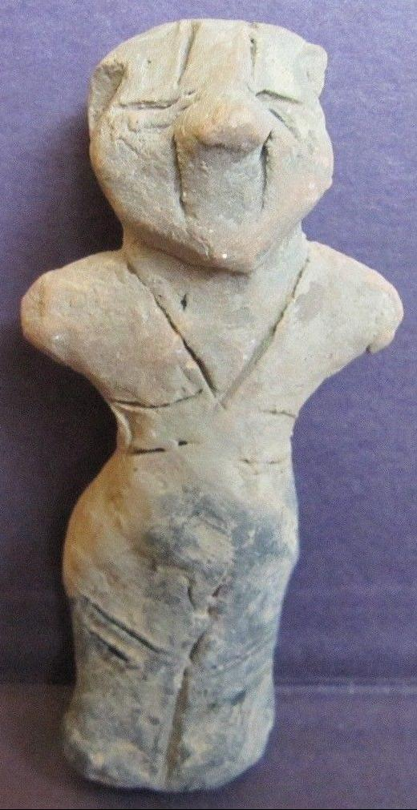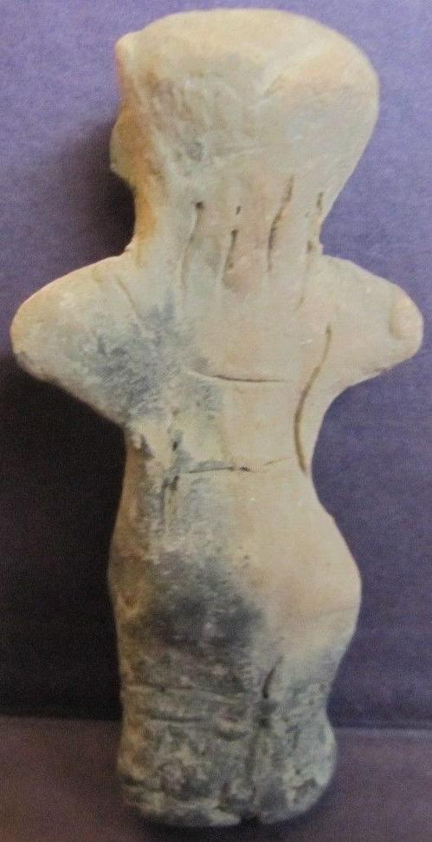

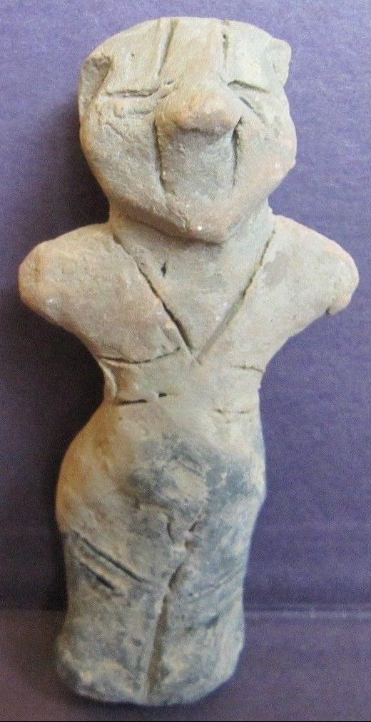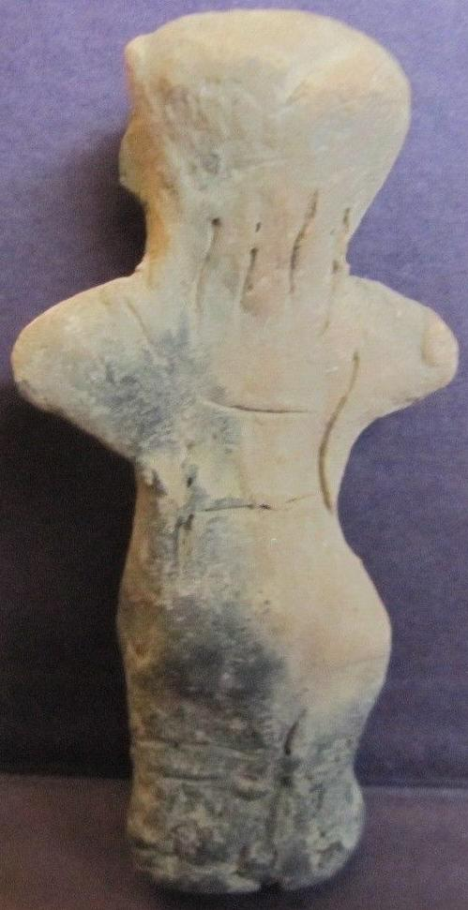 SHAPE \\* MERGEFORMAT 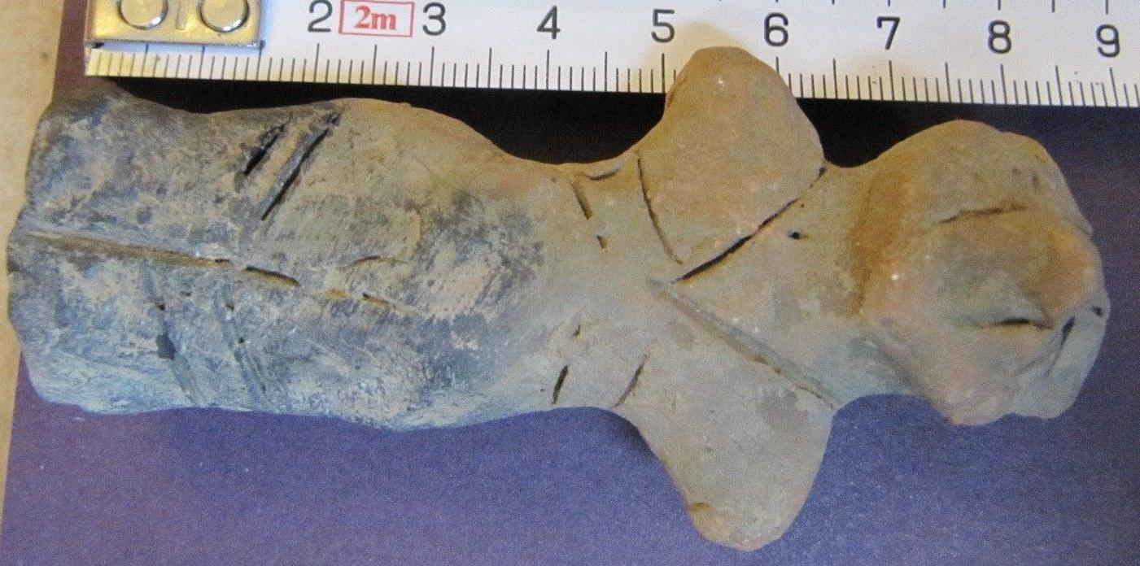

Very Nice Vinca Figurine Idol

Size: 8,50 cm / 3,35 inch

Period: 4500 - 5000 BC

Material : Pug, Terracotta

Condition: fine

Guarantee of Authenticity

